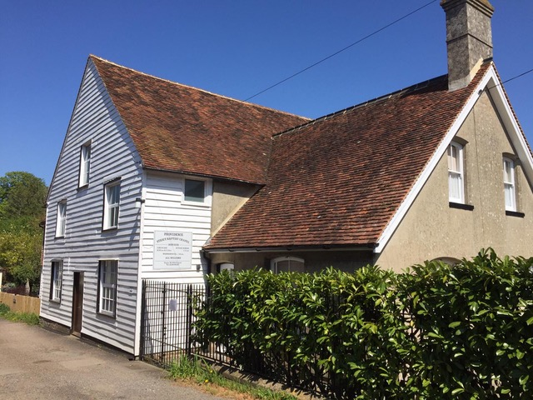
Providence Chapel
Staplehurst
Anniversary Services
D.V.
Saturday 11th May 2024
Dr T. Ramsbottom

Afternoon 3pm

Please stay for refreshments after the service

Collection for Mombasa Mission & Savannah Trust

