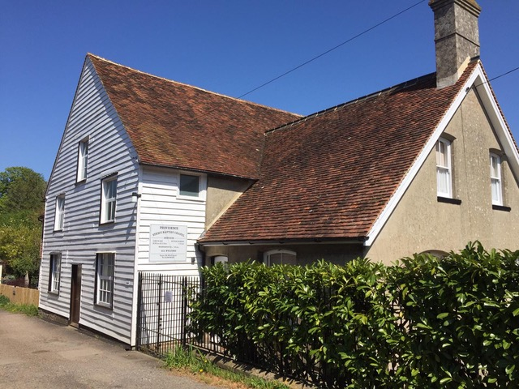
Providence Chapel
Staplehurst
Carol Service
D.V.
Saturday 13th December 2025

Afternoon 3pm

Christmas readings, singing and an address by our Pastor
Marcus Funnell
All welcome to stay for refreshments after the service

